Lab Assignment Day4

01_Aaditya Sudhir Joshi

1. Create table named customer with following columns Customerid int,custname varchar(100),Phone int,Country varchar(100)

a. Add Primary key to customerid column with auto increment option starting with 100

b. Add 10 records in customer table

Answer:- create table customer(

-> Cusid int AUTO_INCREMENT,

-> custname varchar(100),

-> phone int(12),

-> country varchar(100),

-> PRIMARY KEY(Cusid)

-> );

alter table customer

-> auto_increment=100;

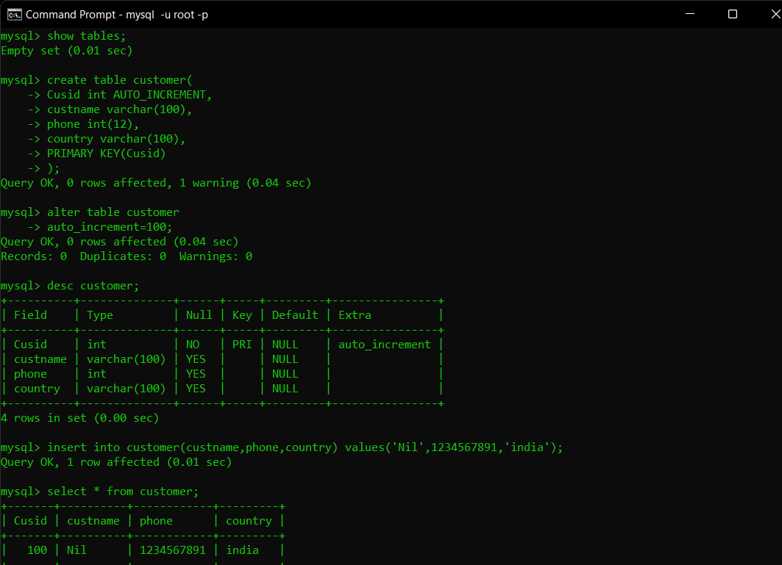

2. Create table named Order with columns Orderid int,itemname varchar(100),price float,custid int

a. Add Primary Key to orderid column

b. Add Foreign Key to custid column references customerid column in customer table

c. Add some records to orders table

Answer:- create table orders(

-> oid int,

-> itemname varchar(100),

-> price float,

-> cusid int,

-> CONSTRAINT FK_order FOREIGN KEY(cusid) REFERENCES customer(Cusid),

-> PRIMARY KEY(oid)

-> );

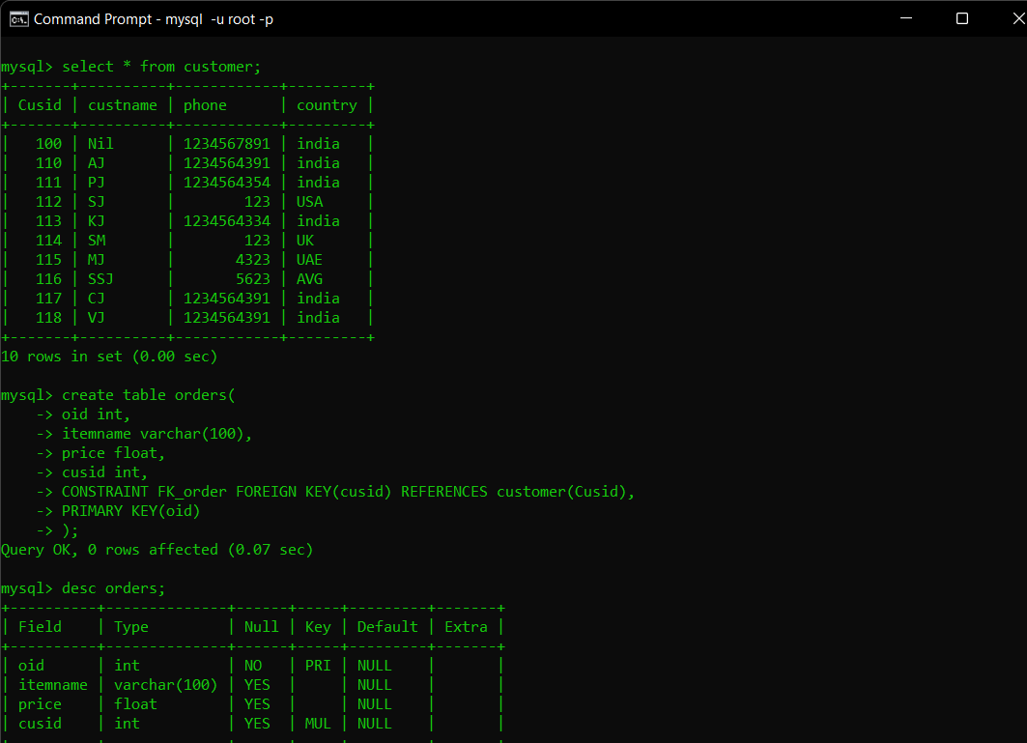

3. Display records from both the tables having matching rows

Answer:=>

select c.*,o.* from customer as c INNER JOIN orders as o ON c.Cusid=o.cusid;

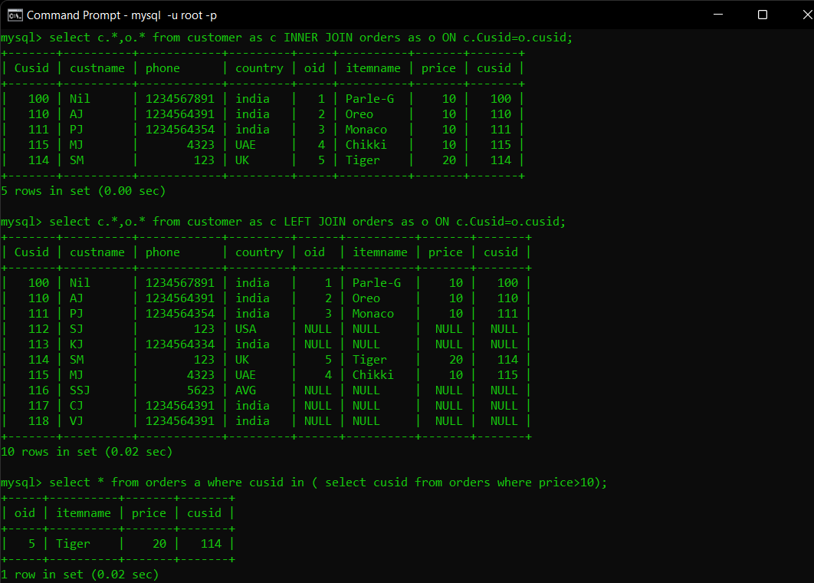

4. Display all records from customer table and matching records from both tables

Answer:=>

select c.*,o.* from customer as c LEFT JOIN orders as o ON c.Cusid=o.cusid;



5. Display customer details where customer had ordered items with price > 10 using subquery from order table

Answer:=>

select * from orders a where cusid in ( select cusid from orders where price>10);



6. Display customers from customers table if and only if the customers have order in orders table.

Answer:=>

select * from customer as c where exists (select * from orders as o where cusid=c.cusid);

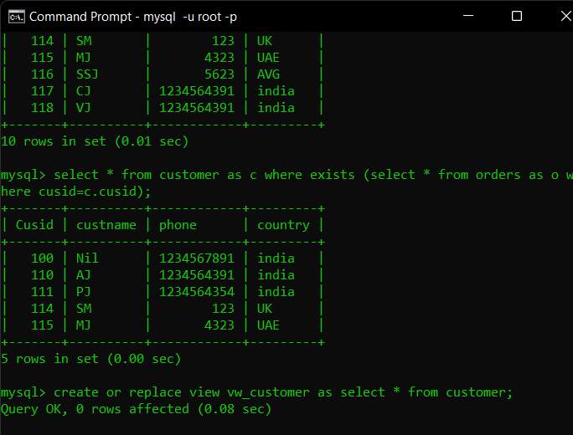

7. Create a replaceable view for customers table only for customers in India with check option. Add a new record in customers table through view

Answer:-

create or replace view vw_customer as select * from customer;

create or replace view vw_customerindia as select * from customer where country='india' with check option;

select * from vw_customerindia;

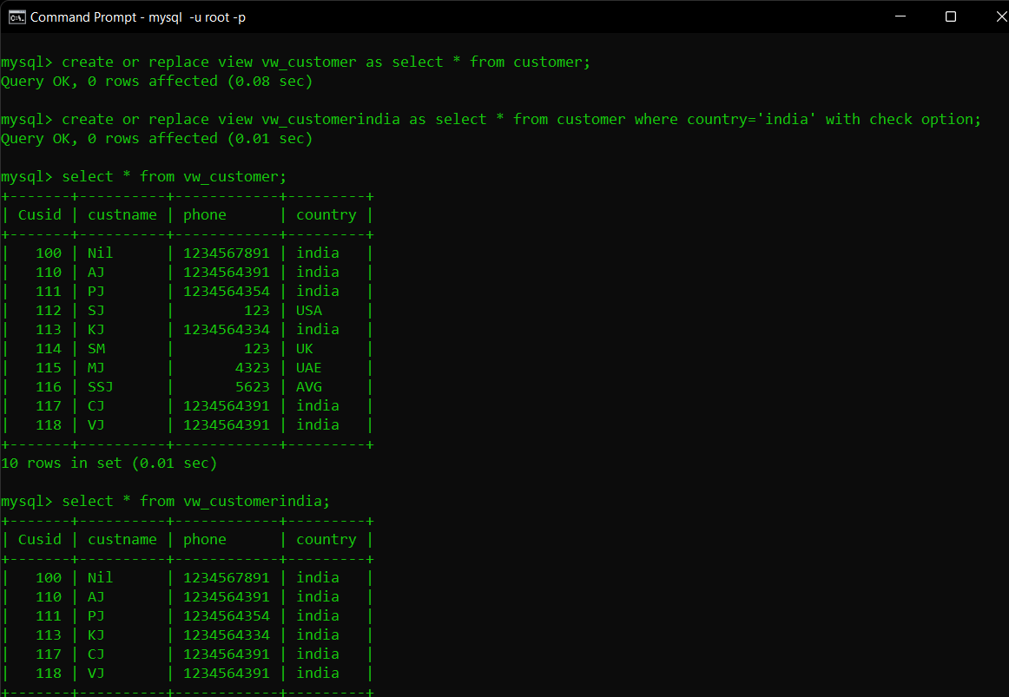

8. Insert 2 more records in orders table and give a savepoint

Display the records in orders table

Delete both newly added records

Display the records in orders table after deletion

Use Rollback command to cancel the delete operation and display the

orders table again

Answer:-

start transaction;

set autocommit=0;

select * from orders;

savepoint insert1;

insert into orders value(6,'Dates','200.00',113),(7,'Kaju',300,112);

savepoint insert2;

delete from orders where oid=7;

ROLLBACK TO insert2;

select * from orders;

